
RAMAIAH
Institute of Technology
USN | 1 | M | S

(Autonomous Institute, Affiliated to VTU)
(Approved by AICTE, New Delhi & Govt. of Karnataka) Accredited by NBA & NAAC with ‘A’ Grade

EXAMINATIONS SEPTEMBER /OCTOBER 2020
SUPPLEMENTARY SEMESTER / GRADE IMPROVEMENT/ RE –REGISTERED CANDIDATES
Program | : | B.E. : Common to all programs | Semester | : | II
Course Name | : | Engineering Mathematics - II | Max. Marks | : | 100
Course Code | : | MA21/MAT201 | Duration | : | 3 Hrs

Instructions to the Candidates:
- Answer any one full question from each unit.

 |  | UNIT- I
1. | a) | Define maxima and minima for the function of two variables. | CO1 | (02)
1. | b) | Prove that 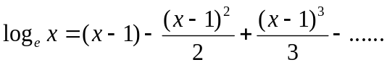. | CO1 | (04)
1. | c) | Show that for the curve 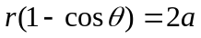, 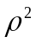varies as 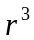. | CO1 | (07)
1. | d) | The temperature at any point 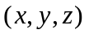in space is 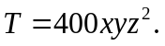Find the highest temperature on the surface of the unit sphere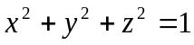. | CO1 | (07)
2. | a) | Define curvature and radius of curvature. | CO1 | (02)
2. | b) | Show that 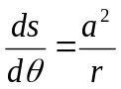 for the curve 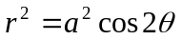. | CO1 | (04)
2. | c) | Expand the function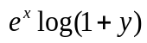at the point (0, 1) up to second degree terms. | CO1 | (07)
2. | d) | Discuss the maxima and minima of 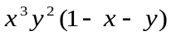. | CO1 | (07)
 |  | UNIT- II
3. | a) | Write the complementary function of the second order LDE 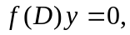 if the roots of the auxiliary equation are imaginary. | CO2 | (02)
3. | b) | If 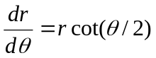is the differential equation of the family of cardioids 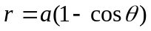, then find its orthogonal trajectory. | CO2 | (04)
3. | c) | The temperature of a cup of coffee is 92⁰ C, when freshly poured and the room temperature being 24⁰ C. In one minute it was cooled to 80⁰ C. How long a period must elapse, before the temperature of the cup becomes 65⁰ C? | CO2 | (07)
3. | d) | Solve the differential equation 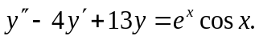 | CO2 | (07)
4. | a) | Write the DE of the closed circuit involving L, C and R in series with applied e.m.f. | CO2 | (02)
4. | b) | Solve the differential equation 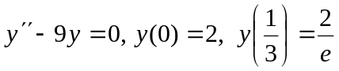. | CO2 | (04)
4. | c) | Show that the family of curves 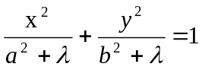 is self-orthogonal, where is the parameter. | CO2 | (07)
4. | d) | Solve the differential equation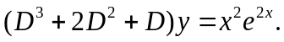 | CO2 | (07)
 |  | UNIT- III
5. | a) | Write a second order general Legendre’s linear differential equation. | CO3 | (02)
5. | b) | Solve the PDE 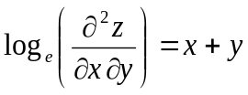by direct integration method. | CO3 | (04)
5. | c) | Solve the differential equation: 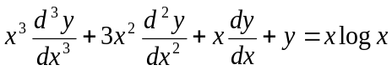. | CO3 | (07)
5. | d) | Solve the following PDE by method of separation of variables 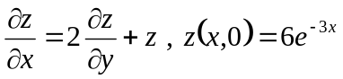. | CO3 | (07)
6. | a) | Define partial differential equation and write one example. | CO3 | (02)
6. | b) | Reduce the following into a linear differential equation with constant coefficients 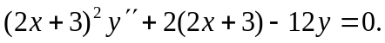 | CO3 | (04)
6. | c) | Solve the following PDE by Lagrange’s method 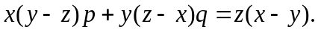 | CO3 | (07)
 | d) | Solve the differential equation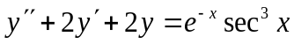by the method of variation of parameters. | CO3 | (07)
 |  | UNIT- IV
7. | a) | Define unit step function and represent graphically. | CO4 | (02)
7. | b) | If 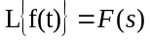 then prove that 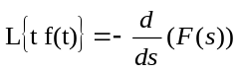. | CO4 | (04)
7. | c) | Find (i)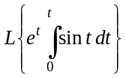 (ii)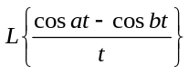. | CO4 | (07)
7. | d) | Show that 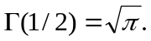 | CO4 | (07)
8. | a) | Write the first shifting property of Laplace transform. | CO4 | (02)
8. | b) | Evaluate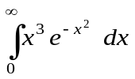. | CO4 | (04)
8. | c) | Express the following function in terms of the Heaviside function and hence find its Laplace transform 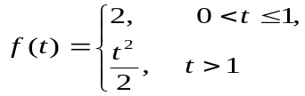 | CO4 | (07)
8. | d) | Evaluate i) 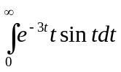 ii) 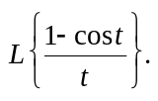 | CO4 | (07)
 |  | UNIT- V
9. | a) | Write the formula for 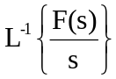. | CO5 | (02)
9. | b) | Evaluate 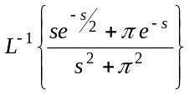. | CO5 | (04)
9. | c) | Using convolution theorem find the inverse Laplace transform of 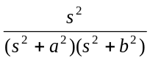. | CO5 | (07)
9. | d) | Using Laplace transform, solve the simultaneous differential equations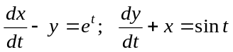, given 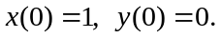 | CO5 | (07)
10. | a) | Define convolution of two functions. | CO5 | (02)
10. | b) | Evaluate 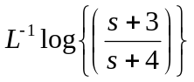. | CO5 | (04)
10. | c) | Find the Laplace transform function of period 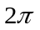, given by 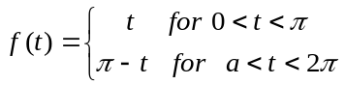. | CO5 | (07)
10. | d) | Solve 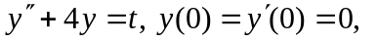using Laplace Transforms. | CO5 | (07)

****************

